18sw32

Nittalia Zaheer Abro

Java lab#1 task

**Task 1:**

Write a program in which declare some variables with valid identifiers, to hold your name, your total marks in previous semester, percentage, your grade, your status of pass or fail (by a Boolean variable) etc, assign them explicitly and print them. Try to declare variables of all (8) data types and assign the appropriate values

**Source code:**

class Myfirstjavaprogram{

public static void main(String args[])

{

String name;

name="nittalia zaheer";

short totalmarks=100;

int marksobtain=90;

char grade='A';

double per=(marksobtain*100)/totalmarks;

boolean t=true;

boolean f=false;

if((per>50)==true)

{

System.out.println("status:pass");

}

else

{

System.out.println("status:notpass");

}

System.out.println("name:"+name);

System.out.println("totalmarks:"+totalmarks);

System.out.println("obtainedmarks:"+marksobtain);

System.out.println("grade:"+grade);

System.out.println("percentage:"+per);

}

}

**Output:**

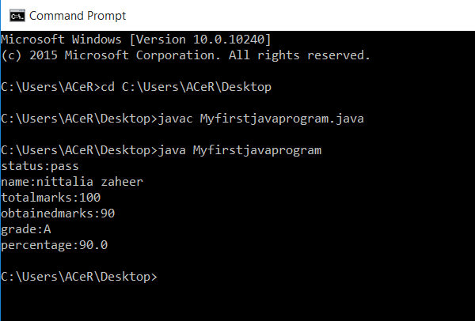

**Task 2:**

Write a program to declare and initialize a double variable with some value such as 50.25. Then retrieve the integral part and store it in the variable of type long, and the fractional part and store it in a variable of type double. Display the actual number, the integral part and the Fractional part.

**Source code**:

**class SecondTask{**

**public static void main (String[] args)**

**{**

**double i= 50.25;**

**long j= (long) i;**

**double k= i-j;**

**System.out.println("actual number"+i);**

**System.out.println("integral part"+j);**

**System.out.println("fractional part"+k);**

**}**

**}**

**Output:**

